University of the Fraser Valley

COMP 340 – MIDTERM EXAMINATION

February 13th, 2023

NAME:___Qiu__________zhiwei____________
FAMILY NAME GIVEN NAMES

UFV-ID #:____300191315_________________

INSTRUCTIONS

- This is a 24-hour take-home examination.
- Clearly print your name and student ID number on this examination (above).
- No collaboration is allowed.
- You are allowed to use any reference, but it must be cited.
- No copying and pasting of code is allowed.
- There are 55 points in total.
- There are 2 pages including this cover sheet.
- Submit your answers in Word format to the UFV Blackboard submission server AND email it to steven.pearce@ufv.ca no later than 8:30 am, Tuesday, February 14, 2023 (Happy Valentine’s Day).



- [6] The use of multiple threads in a process has two obvious advantages. Discuss them in detail. Does the use of multiple threads also improve the ability to implement a mode switch? Explain in detail.

The first benefit is that they can share a resource. Because one process can have multiple threads, all threads in that process can share the same resource. So with multiple threads, a process can divide its operations into different threads and allocate resources more efficiently, which results in better resource use.
The second advantage is that it can improve process efficiency. With multiple threads, a process can run in parallel, which means that it can assign different jobs to different threads to finish at the same time, allowing it to do multiple jobs simultaneously.
Yes, because one advantage of a thread is that switching between two or more threads takes less time than switching between processes. So, to perform some operations, one process can be divided into multiple threads, and the OS can perform context switching between these threads rather than the process itself, reducing time and cost in context switching.

- Consider the following state-transition diagram:

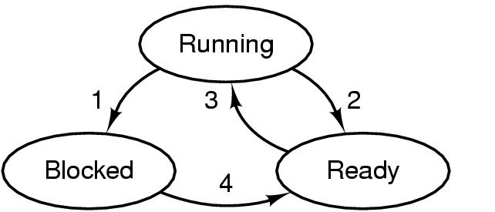
Indicate what each of the four transitions refers to in detail [4]:

1: Process block for input. When the operating system selects a process that requests a resource that cannot be used right now, it is placed in the blocked state, a transition known as "events await."
4: Input becomes available. When the waiting process receives the requested resource, which is known as events, and they occur and become available, the OS will return it to the ready state.
2: The scheduler picks another process. Running state to ready state happens when the OS decides to interrupt a running process, such as by a clock interrupt, an I/O interrupt, an operating system call, or another form of signal.
3: This process is chosen by the scheduler. Ready state to running happens when the scheduler dispatcher picks a process in the ready queue based on scheduling algorithms and then moves it to the running state.

Next, discuss the viability of the missing two transitions [2]:
When a new process is created and admitted to the operating system, it is referred to as an admitted transition. When a new process comes in, it cannot run; it should wait for the OS to allocate memory and make arrangements for it.
Exit always occurs when a process is completed and finished, most of the time, this means the process was executed so that it can move away, don’t need it
.
- [5] Describe in detail how you would design a suspended state into the 3-state model above in practice and at the level of the instruction cycle [5]

A "suspended" process means that the scheduler decided to put a "running" process in the "suspend queue," which will keep track of the status and get ready for the process to return to "running" status.
I would design a suspended state the same as a blocked state, but with a little bit of a difference.
When a process is running, it can transfer into a block state based on what the scheduler has decided, and then it can move into a suspend state. The operating system can then decide whether this process should be moved from the suspend state to the ready state.
Also, there should be another transition from ready states to suspended states. Medium-term scheduling should be used to determine the transition from a block state to a ready state.

- [3] Suppose that you were to design an advanced computer architecture that did process switching in hardware, instead of having interrupts. What information would the CPU need? Describe how the hardware process switching might work.

PCB is needed, the OS can use the information to switch between processes.
In process switching in hardware: Hardware stack program counter and register needed.
When the CPU needs a context switch for a process, it will store current information, such as the program counter, into the stack. The next CPU will select the next process to run according to the last recording information, restore this information, and then resume the status.

- [35] Construct both SJF and SJF with preemption process schedulers in one multiple-queue program that compiles in C. Run a few examples and compare how the two algorithms perform given variation in the input processes (be sure to use both CPU-bound and I/O-bound processes in your examples). Also, formally discuss the degree of multiprogramming for each of your example runs. Be sure to comment thoroughly throughout your code describing each major step in detail. (Attach your source code and screen shots to demonstrate that it compiles). If you use Visual Studio, then attach those files so I can easily run them myself. If you use another IDE, then attach those application-specific files instead. DO NOT JUST PLACE CODE INTO THIS WORD DOCUMENT.
Question 5 in another file, please check it.

